South Dakota FFA Association
2020 Agricultural Education
Scholarship Information

The Agricultural Education Scholarship is provided by the South Dakota FFA Association to a South Dakota high school senior who is a current FFA member. The FFA member must be planning to attend South Dakota State University to major in Agricultural Education in the fall semester of the current year. One scholarship in the amount of $500 will be awarded.

Instructions:
- Type all information using size 10 or 12 point font (Times New Roman, Calibri, or Arial). Handwritten applications will not be accepted.
- Complete all sections of the application
- List information chronologically beginning with the earliest date first.
- Use only the space provided.
- Applications must include two confidential letters of recommendation addressing the member’s character, potential for success, etc. Once letter must be from the FFA member’s local advisor and the other letter from another person knowledgeable about the applicant.
- Letters of recommendation should be no longer than one page and signed.
- All signatures must be included in this application
- Application must be emailed to Jeanette.klein@sdstate.edu by 11:59pm CST on February 21st.
- Advisors – reference must be emailed to Jeanette.Klein@sdstate.edu by 11:59pm CST on February 21st. Please see www.sdaged.com for a guideline on the advisor recommendation letter.
Procedure/Recognition:
- Applications will be evaluated for content.
- Chapter advisors will be notified of selected recipients in March. A list of recipients will also be posted at sdaged.org
- Recipients will be recognized at the Monday afternoon session of the SD State FFA Convention in April.
- Selected recipients should send a thank you to:

South Dakota FFA Association
39393 133rd St
Bath, SD 57427

- Checks will be mailed to the recipient after a copy of the recipient’s class schedule for the spring semester and unofficial transcript proving a 2.0 GPA for the completed fall semester has been received. Please send these documents by December 15, 2020 to:

South Dakota FFA Foundation
Gretchen Sharp
Box 507, SDSU
Brookings, SD 57007

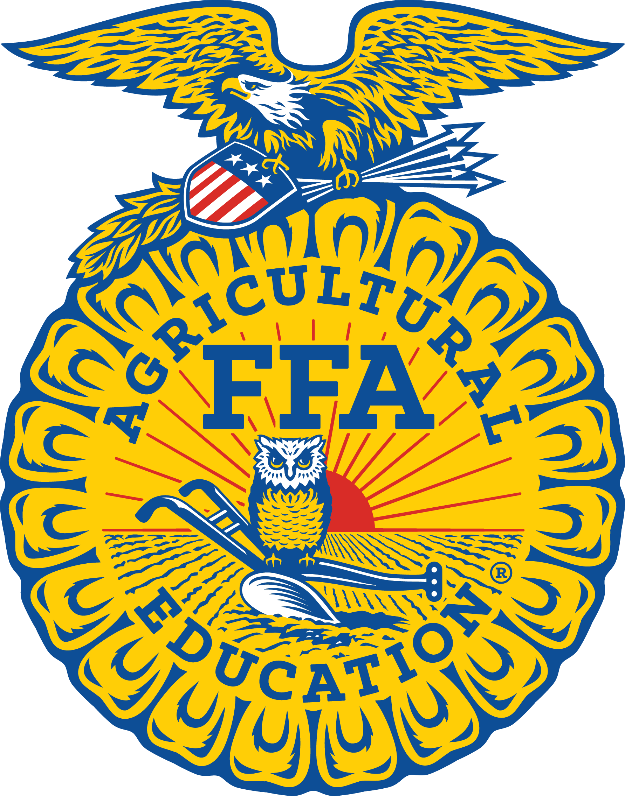
South Dakota FFA Association
2020 Agricultural Education
Scholarship Application

Name |  | Chapter

Email address |  | FFA member ID #

Grade in School |  | Years of FFA membership

Address |  | City

State |  | Zip

- Please list your FFA activities and accomplishments, including dates.
- Please list any FFA offices held and dates.
- Please list your non-FFA school and community activities and achievements.
- Please include a personal statement indicating your scholarship qualifications including academic interest, planned SDSU activities, career objectives, and other applicable information.

A knowledgeable high school official must complete this section:

Class Rank |  | out of
ACT or SAT Score |  | GPA

Name and Title |  | High School
Signature |  | Date

I have personally prepared this application and certify that it accurately reflects my work.
Signature of Applicant |  | Date

We have reviewed this application and believe the information provided is accurate.
Signature of Parent or Guardian |  | Date
Signature of FFA Chapter Advisor |  | Date

